**C-DAC Mumbai Date 25/09/2024**

**Subject: Algorithm and Data Structure**

**Assignment 1**

**Solve the assignment with following thing to be added in each question.**

-Program

-Flow chart

-Explanation

-Output

-Time and Space complexity

1. Armstrong Number

Problem: Write a Java program to check if a given number is an Armstrong number.

Test Cases:

Input: 153

Output: true

Input: 123

Output: false

Sol:

public class Armstrong {

public static void main(String[] args) {

// **TODO** Auto-generated method stub

Scanner sc = new Scanner(System.***in***);

System.***out***.print("Enter : ");

int n = sc.nextInt();

int m=n, count=0, t=0, ans=0

while (m > 0) {

m = m / 10;

count++;

}

m = n;

for (int i = 0; i < count; i++) {

t = m % 10;

ans += (int) Math.*pow*(t, count);

m = m / 10;

}

if ( ans == n ) {

System.***out***.println(n + " is a Armstrong number");

}

else {

System.***out***.println(n + " is not a Armstrong number");

}

}

}

O/P:

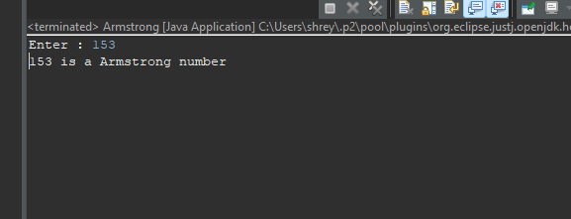

FlowChart:

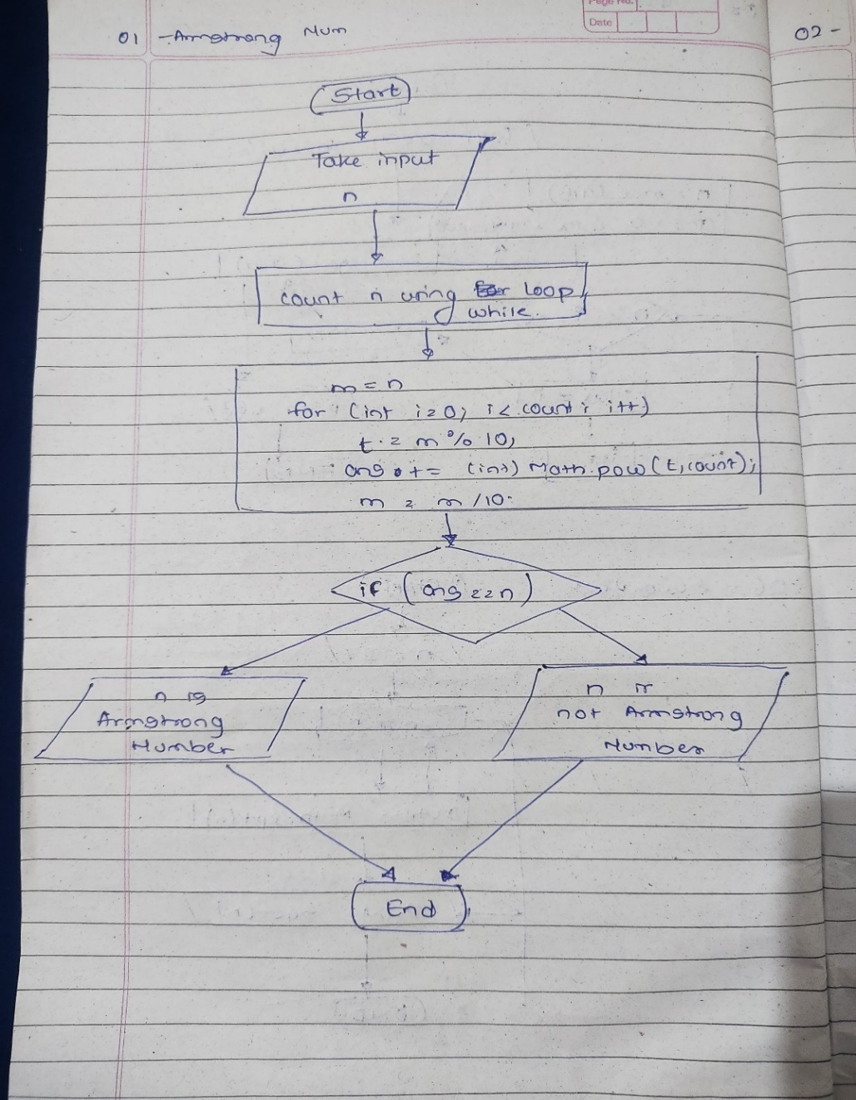

Time Com : O(n) Space Com : O(1)

2. Prime Number

Problem: Write a Java program to check if a given number is prime.

Test Cases:

Input: 29

Output: true

Input: 15

Output: false

SOL:

public class Prime_No {

public static void main(String[] args) {

// **TODO** Auto-generated method stub

Scanner sc = new Scanner(System.***in***);

System.***out***.print("Enter : ");

int n = sc.nextInt(),ans=1;

if ( n <= 1) {

ans = 0;

}

else if ( n == 2 || n == 3 ) {

ans = 1;

}

for (int i = 2; i <= Math.*sqrt*(n); i++) {

if ( n % i == 0) {

ans = 0;

break;

}

}

if (ans == 1) {

System.***out***.println(n+" is a prime number");

}

else {

System.***out***.println(n+" is not a prime number");

}

}

}

O/P: 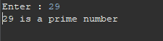

FlowChart :

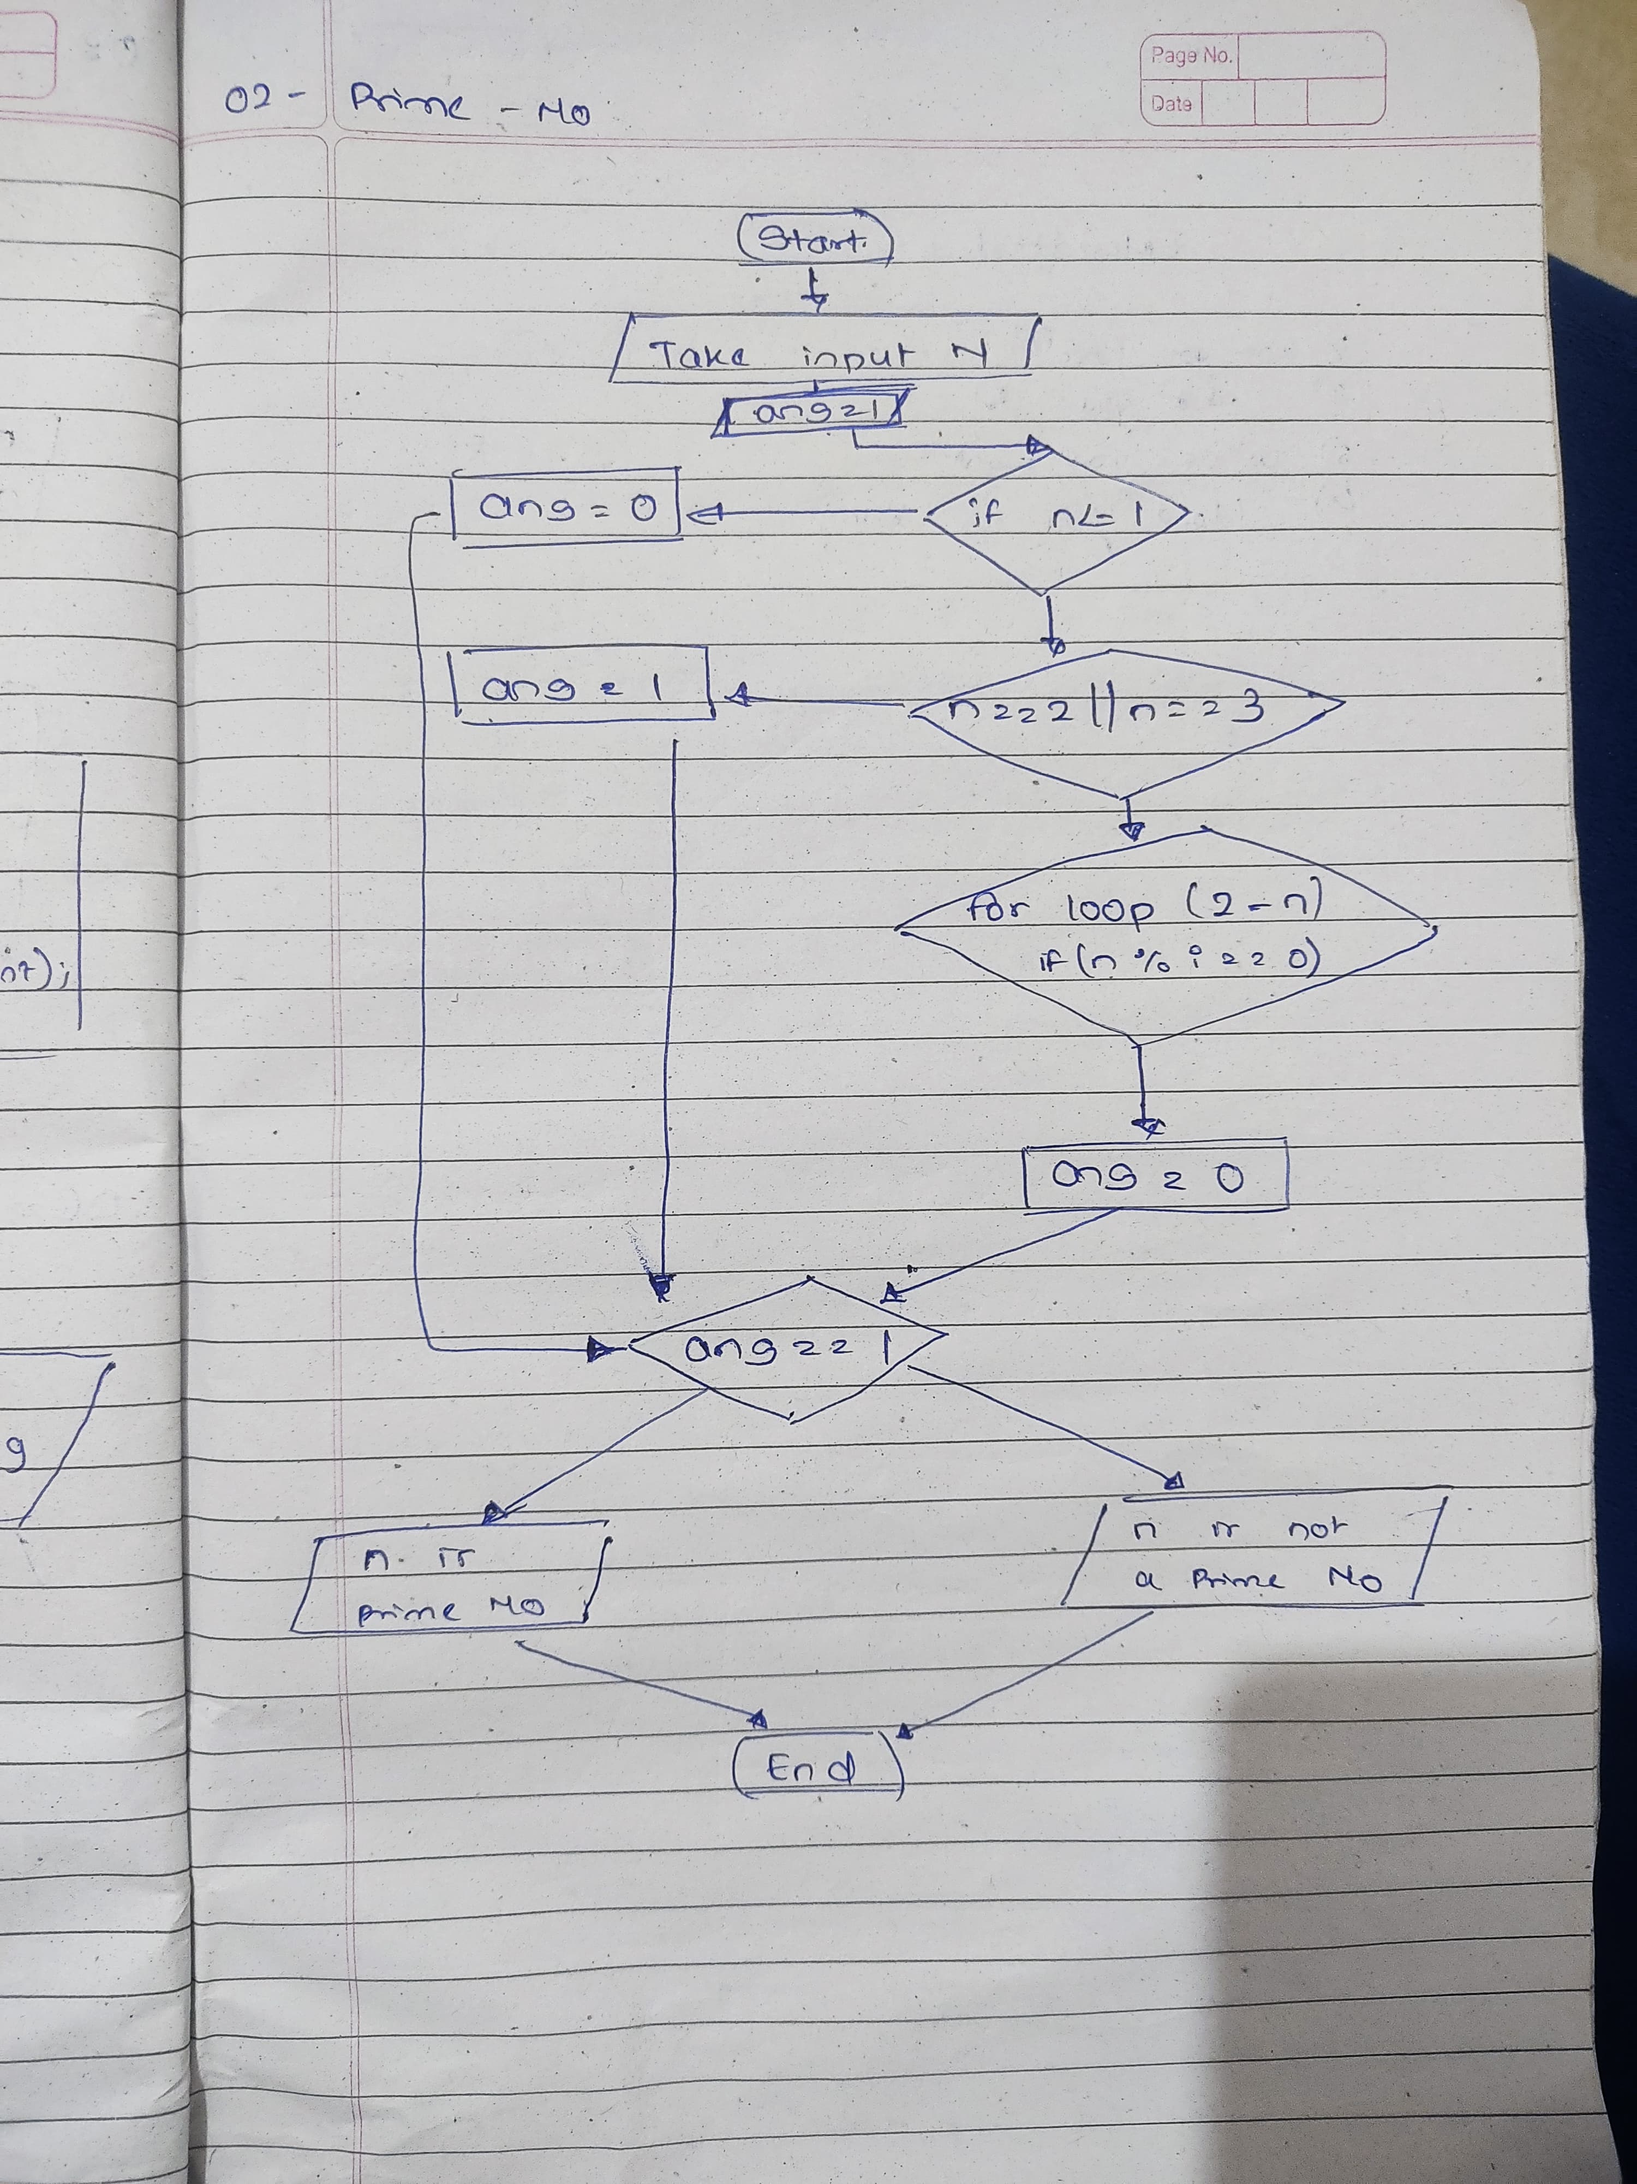

Time Com : O(SquareRootOf N) Space Com : O(1)

3. Factorial

Problem: Write a Java program to compute the factorial of a given number.

Test Cases:

Input: 5

Output: 120

Input: 0

Output: 1

Code :

public static void main(String[] args) {

Scanner sc = new Scanner(System.***in***);

System.***out***.print("Enter : ");

int n = sc.nextInt(), fact = 1;

for (int i = 1; i <= n; i++) {

fact *=i;

}

System.***out***.print("Fact : "+fact);

}

O/P:

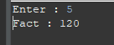

FlowChart:

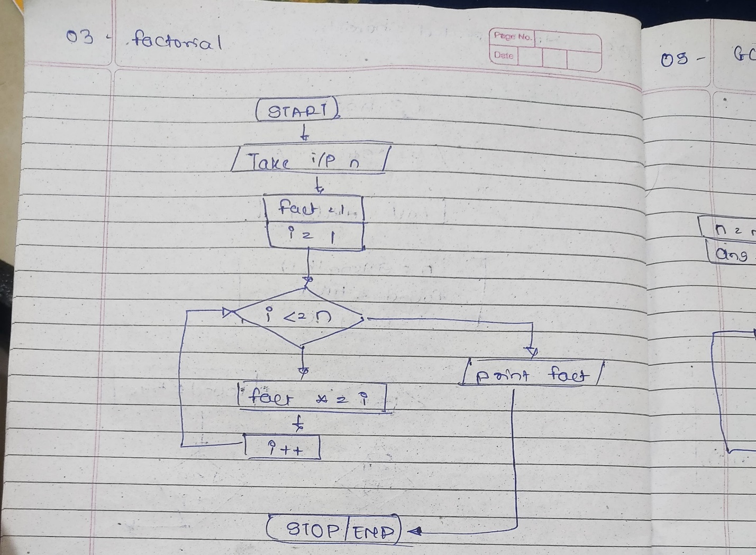

Time Com : O(n) Space Com : O(1)

4. Fibonacci Series

Problem: Write a Java program to print the first n numbers in the Fibonacci series.

Test Cases:

Input: n = 5

Output: [0, 1, 1, 2, 3]

Input: n = 8

Output: [0, 1, 1, 2, 3, 5, 8, 13]

Code :

static int display(int n) {

if (n <= 1) {

return n;

}

return *display*(n-1) + *display*(n-2);

}

public static void main(String[] args) {

// **TODO** Auto-generated method stub

int n = 5;

for (int i = 0; i <= n; i++) {

System.***out***.print(*display*(i)+" ");

}

}

O/P:

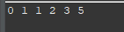

FlowChart :

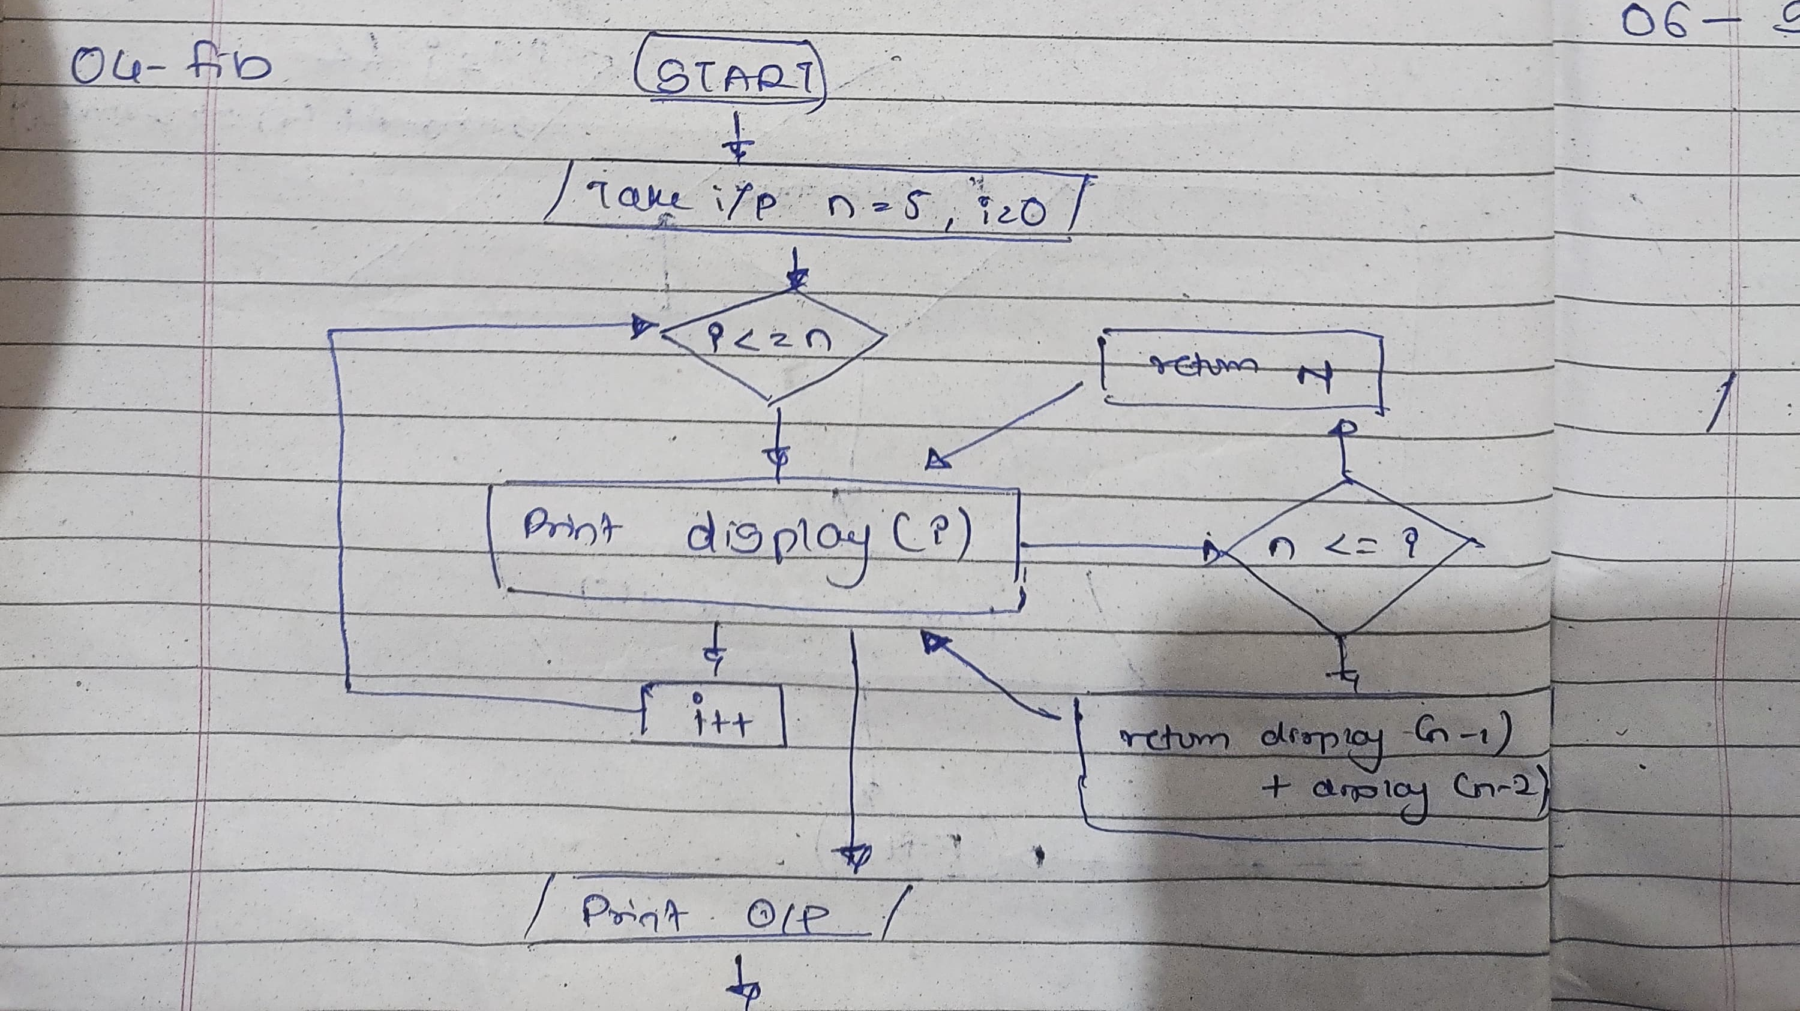

Time Com : O(2^n) Space Com : O(1)

5. Find GCD

Problem: Write a Java program to find the Greatest Common Divisor (GCD) of two numbers.

Test Cases:

Input: a = 54, b = 24

Output: 6

Input: a = 17, b = 13

Output: 1

Code :

static int gcd(int a, int b) {

int n = Math.*max*(a, b);

int ans=0, max = Integer.***MIN_VALUE***;

for (int i = 1; i <= Math.*sqrt*(n); i++) {

if (n % i == 0) {

max = i;

}

}

return max;

}

public static void main(String[] args) {

// **TODO** Auto-generated method stub

int a = 54;

int b = 24;

System.***out***.println(*gcd*(a,b));;

}

O/P:

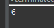

FlowChart:

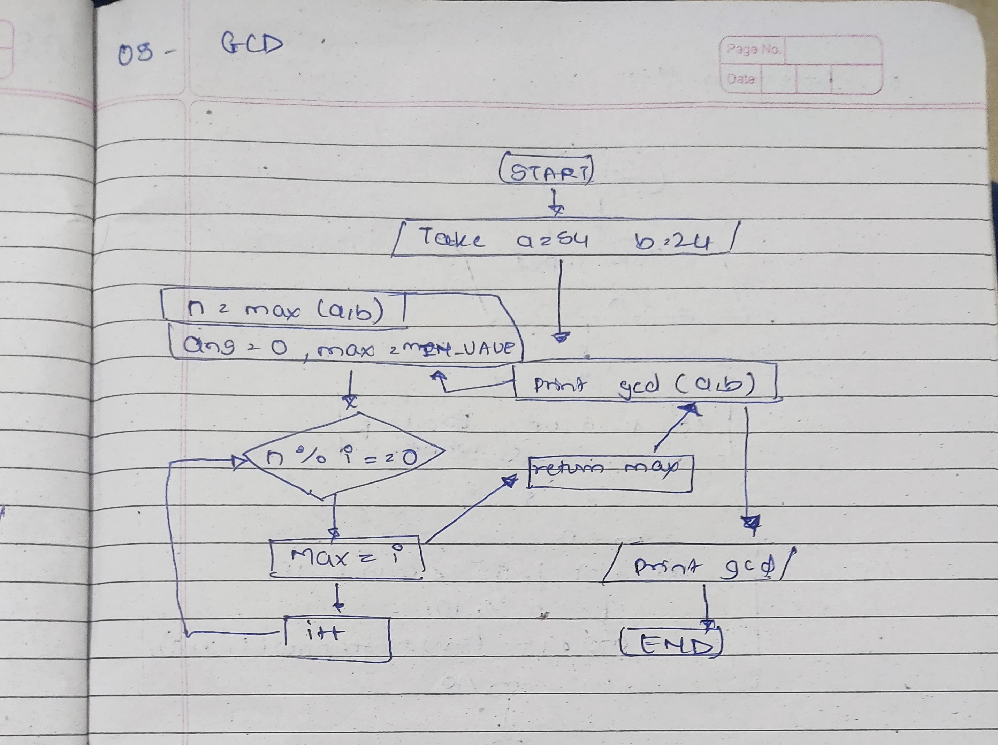

Time Com : O(SquareRootOf N) Space Com : O(1)

6. Find Square Root

Problem: Write a Java program to find the square root of a given number (using integer approximation).

Test Cases:

Input: x = 16

Output: 4

Input: x = 27

Output: 5

Code :

static int squr(int n) {

return (int) Math.*sqrt*(n);

}

public static void main(String[] args) {

// **TODO** Auto-generated method stub

int n = 27;

System.***out***.println(*squr*(n));;

}

O/P:

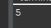

FlowChart:

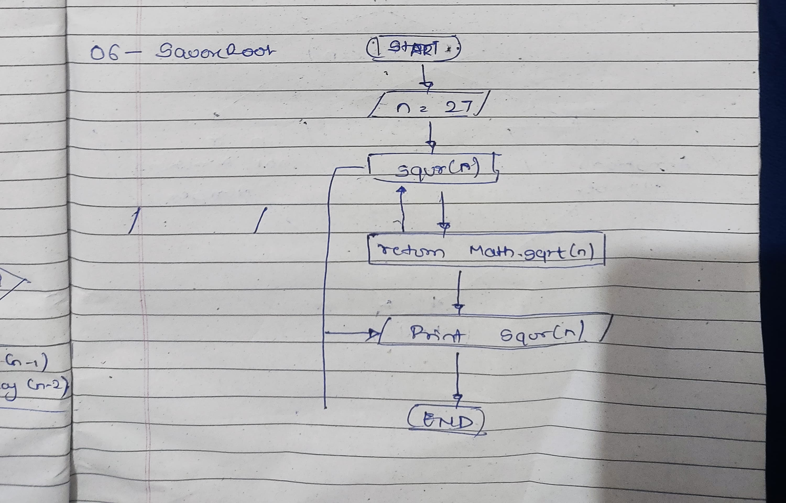

Time Com : O(1) Space Com : O(1)

7. Find Repeated Characters in a String

Problem: Write a Java program to find all repeated characters in a string.

Test Cases:

Input: "programming"

Output: ['r', 'g', 'm']

Input: "hello"

Output: ['l']

Code :

public static void NRC(String s)

{

int n = s.length();

for (int i = 0; i < n; ++i) {

for (int j = i+1; j < n; ++j) {

if ( s.charAt(i) == s.charAt(j)) {

System.***out***.print(s.charAt(i)+" ");

}

}

}

}

public static void main(String[] args) {

String s = "programming";

*NRC*(s);

}

O/P:

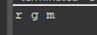

Time Com : O(n^2) Space Com : O(1)

FlowChart:

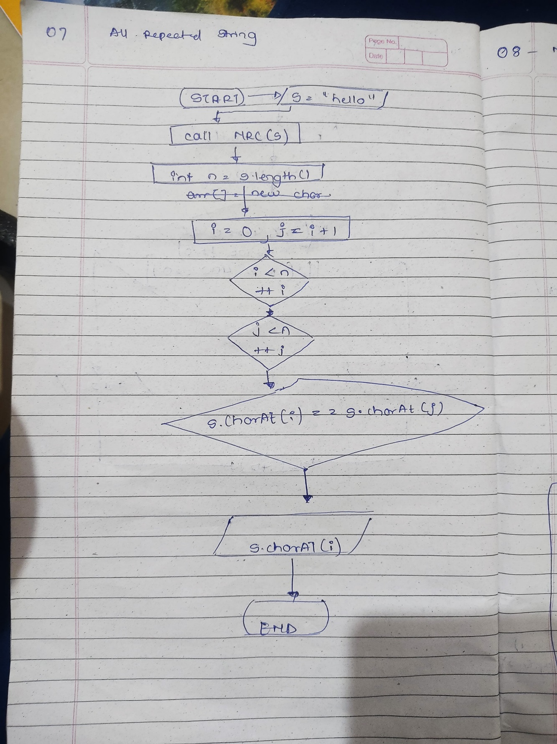

8. First Non-Repeated Character

Problem: Write a Java program to find the first non-repeated character in a string.

Test Cases:

Input: "stress"

Output: 't'

Input: "aabbcc"

Output: null

Code :

public static void NRC(String s) {

int n = s.length();

boolean found = false;

for (int i = 0; i < n; ++i) {

found = true;

for (int j = 0; j < n; ++j) {

if (i != j && s.charAt(i) == s.charAt(j)) {

found = false;

break;

}

}

if (found) {

System.***out***.println("First non-repeated character : " + s.charAt(i));

return;

}

}

System.***out***.println("No non-repeated character found.");

}

public static void main(String[] args) {

// **TODO** Auto-generated method stub

String s = "stress";

*NRC*(s);

}

O/P:

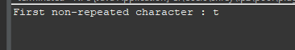

FlowChart:

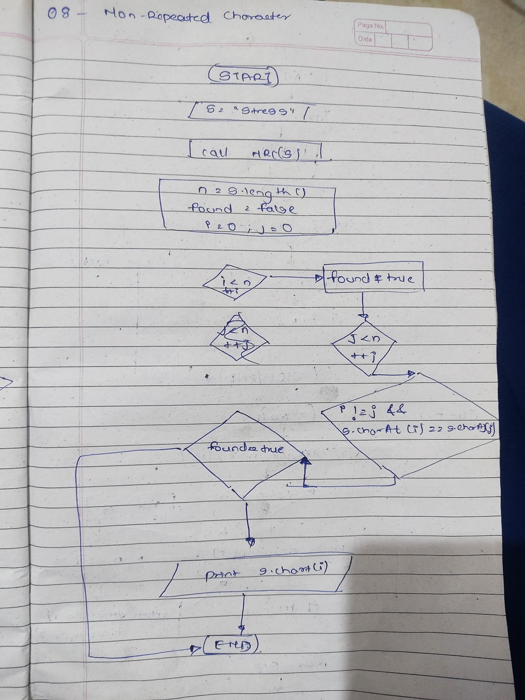

Time Com : O(n^2) Space Com : O(1)

9. Integer Palindrome

Problem: Write a Java program to check if a given integer is a palindrome.

Test Cases:

Input: 121

Output: true

Input: -121

Output: false

Code :

public static void main(String[] args) {

Scanner sc = new Scanner(System.***in***);

System.***out***.print("Enter the number : ");

int n = sc.nextInt();

int m=n,c=0, compare = n;

while (m > 0) {

m = m/10;

c++;

}

m = 0;

int rev =0;

for (int i = 0; i < c; i++) {

m = n % 10;

rev = rev * 10 + m ;

n = n / 10;

}

if (rev == compare ) {

System.***out***.println("true");

}

else {

System.***out***.println("false");

}

}

O/P:

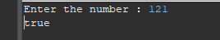

FlowChart:

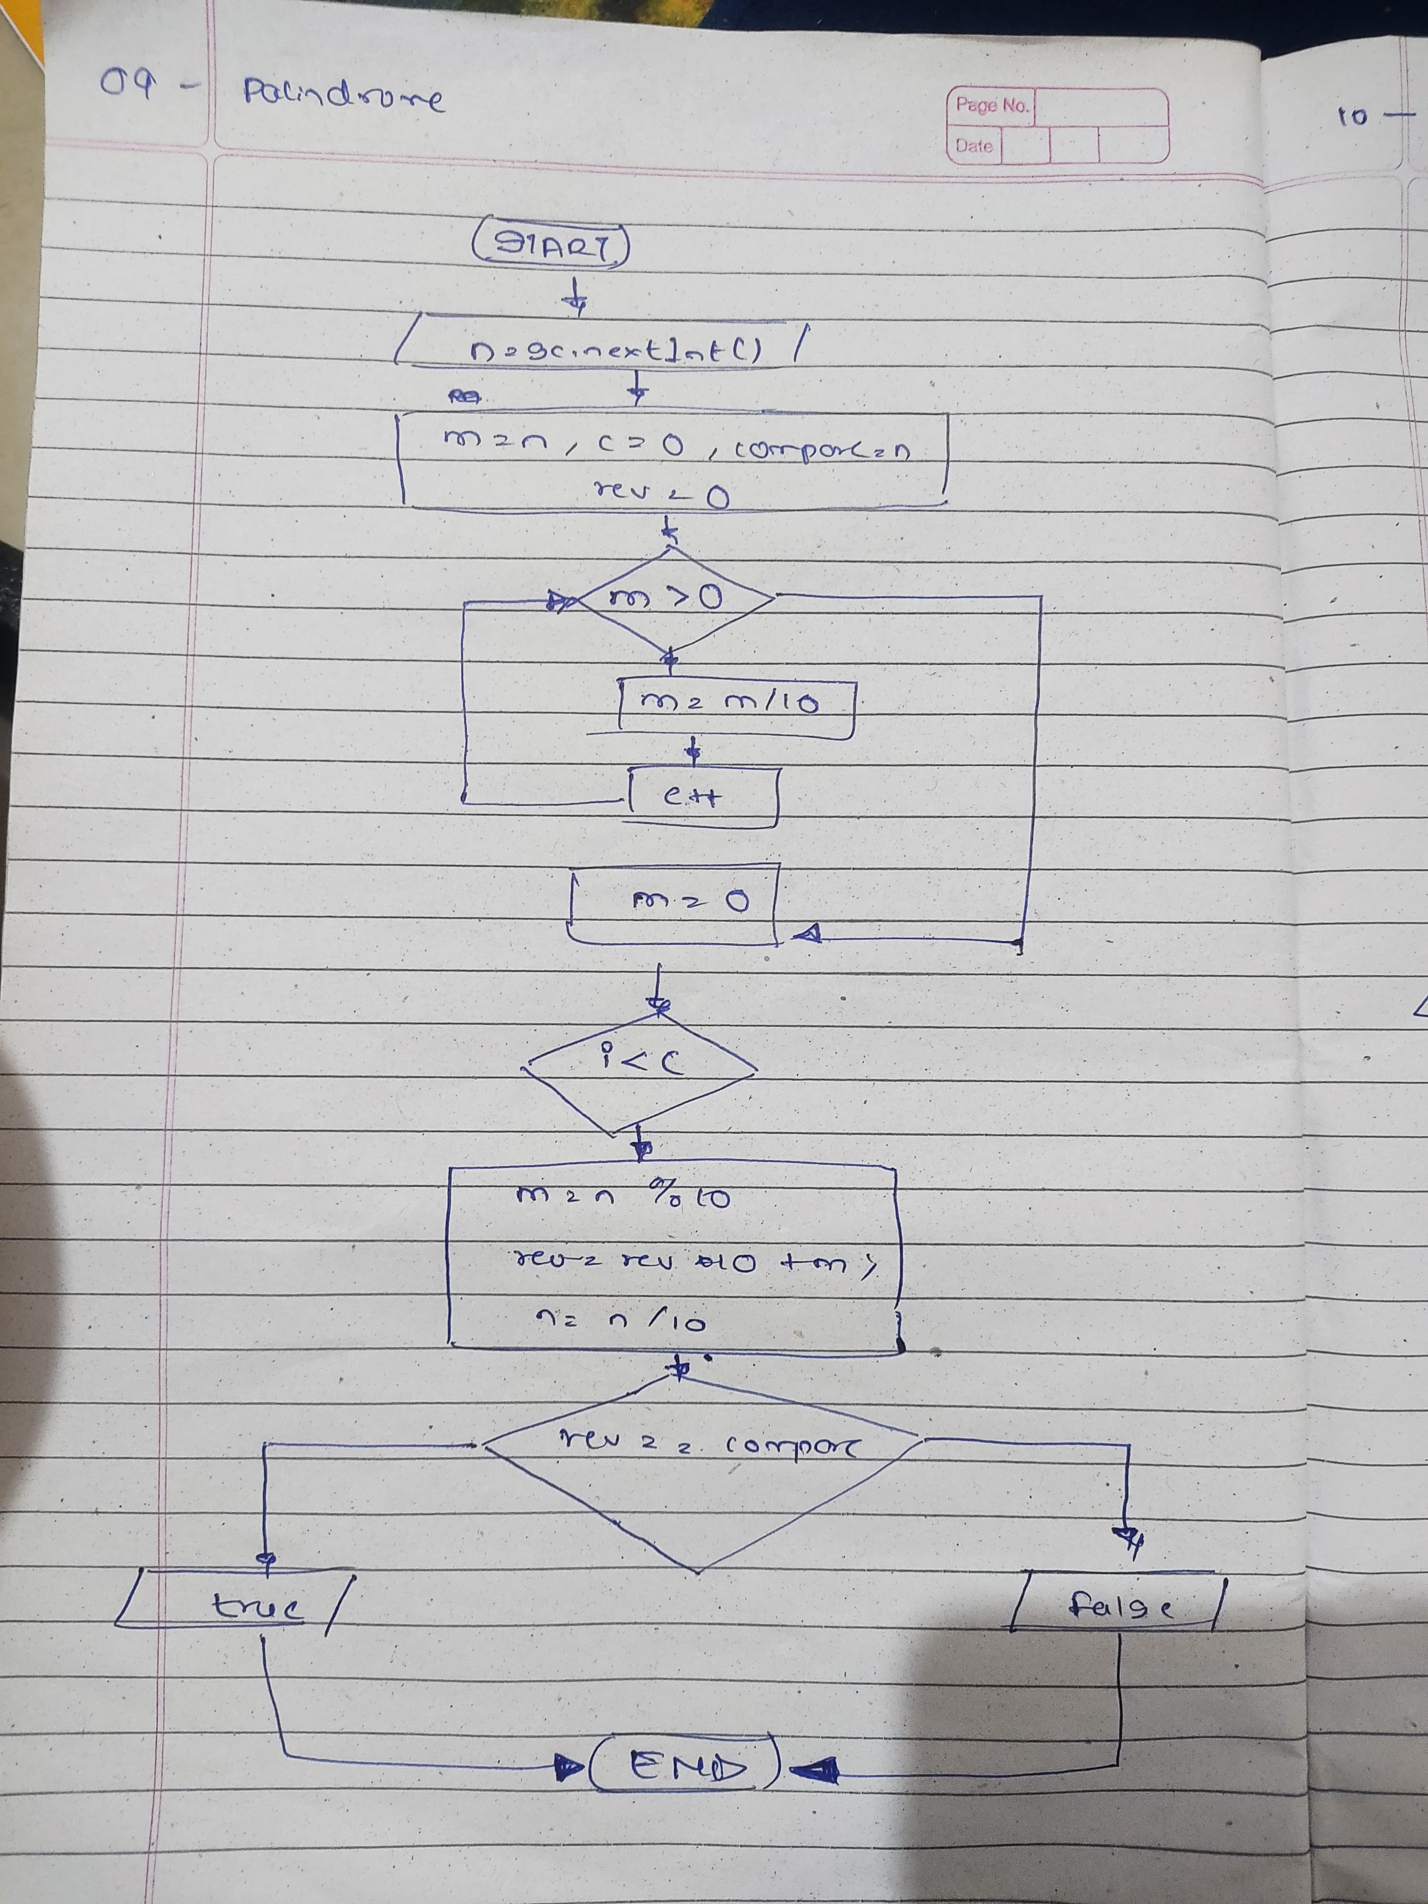

Time Com : O(n) Space Com : O(1)

10. Leap Year

Problem: Write a Java program to check if a given year is a leap year.

Test Cases:

Input: 2020

Output: true

Input: 1900

Output: false

Code:

public static void main(String[] args) {

// **TODO** Auto-generated method stub

Scanner sc = new Scanner(System.***in***);

System.***out***.print("Enter : ");

int n = sc.nextInt();

boolean a = false ;

if (( n % 4 == 0 && n % 100 != 0) || (n % 400 == 0)){

a = true;

}

System.***out***.println(a);

}

O/P:

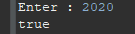

FlowChart:

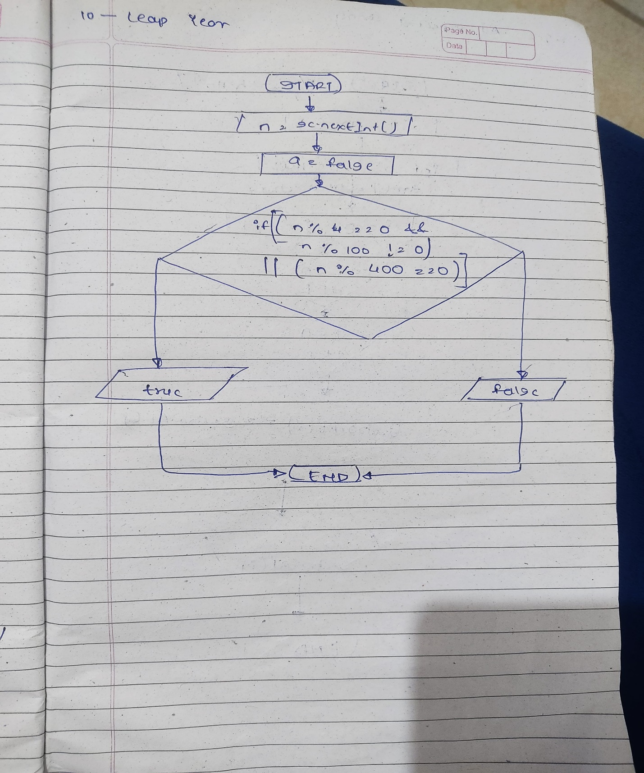

Time Com : O(1) Space Com : O(1)